Playwright
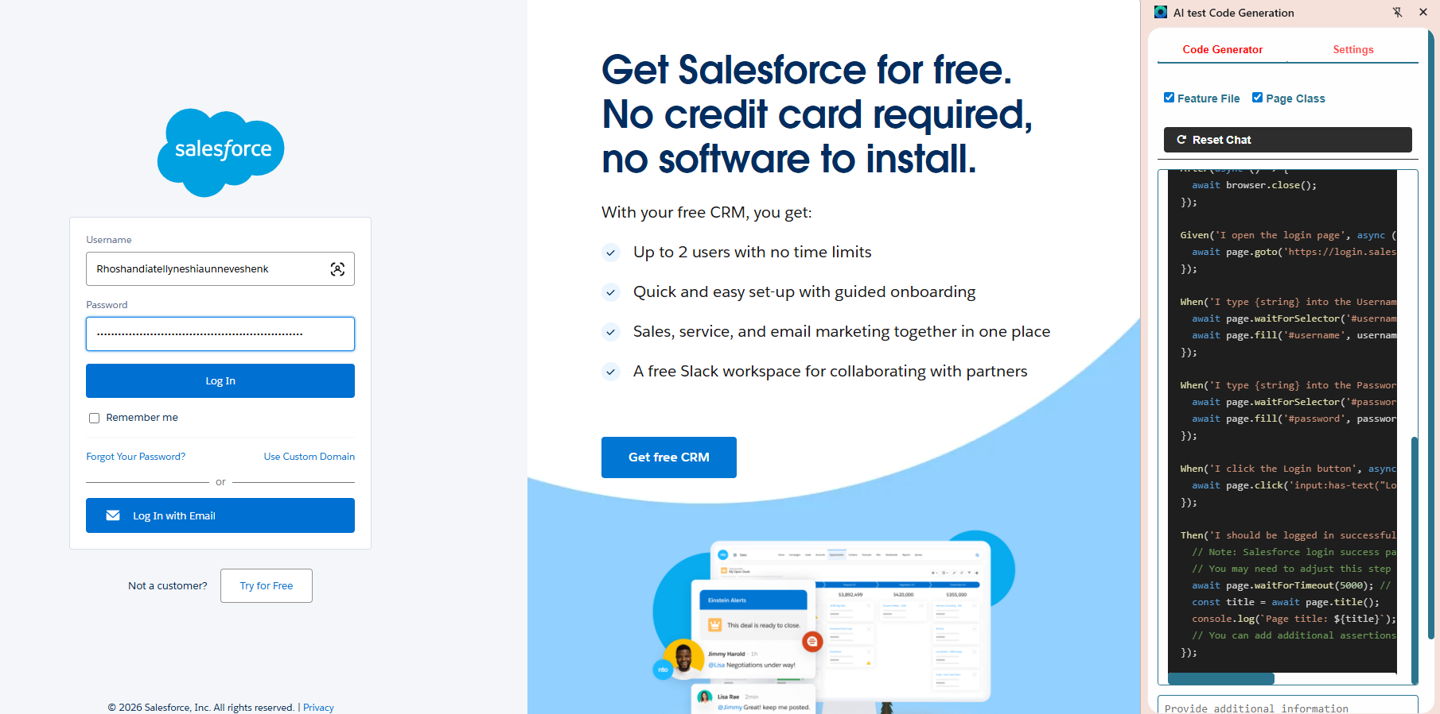
Feature: Login to Salesforce

Scenario Outline: Successful login with valid credentials
Given I open the login page
When I type "<username>" into the Username field
And I type "<password>" into the Password field
And I click the Login button
Then I should be logged in successfully

Examples:
| username | password |
| "ravi.kumar@gmail.com" | "Ravi@123" |
| "suresh.menon@gmail.com"| "Suresh@123" |
| "priya.sharma@gmail.com"| "Priya@123" |

import { Given, When, Then, Before, After } from '@cucumber/cucumber';
import { Page, Browser, chromium } from 'playwright';

let browser: Browser;
let page: Page;

Before(async () => {
browser = await chromium.launch();
page = await browser.newPage();
await page.goto('https://login.salesforce.com/');
});

After(async () => {
await browser.close();
});

Given('I open the login page', async () => {
await page.goto('https://login.salesforce.com/');
});

When('I type {string} into the Username field', async (username: string) => {
await page.waitForSelector('#username');
await page.fill('#username', username);
});

When('I type {string} into the Password field', async (password: string) => {
await page.waitForSelector('#password');
await page.fill('#password', password);
});

When('I click the Login button', async () => {
await page.click('input:has-text("Log In")');
});

Then('I should be logged in successfully', async () => {
// Note: Salesforce login success page does not have a clear success message.
// You may need to adjust this step based on the actual page structure.
await page.waitForTimeout(5000); // Wait for 5 seconds to allow the page to load
const title = await page.title();
console.log(`Page title: ${title}`);
// You can add additional assertions here based on the page content.
});

Use Bugmagnet extension for form filling
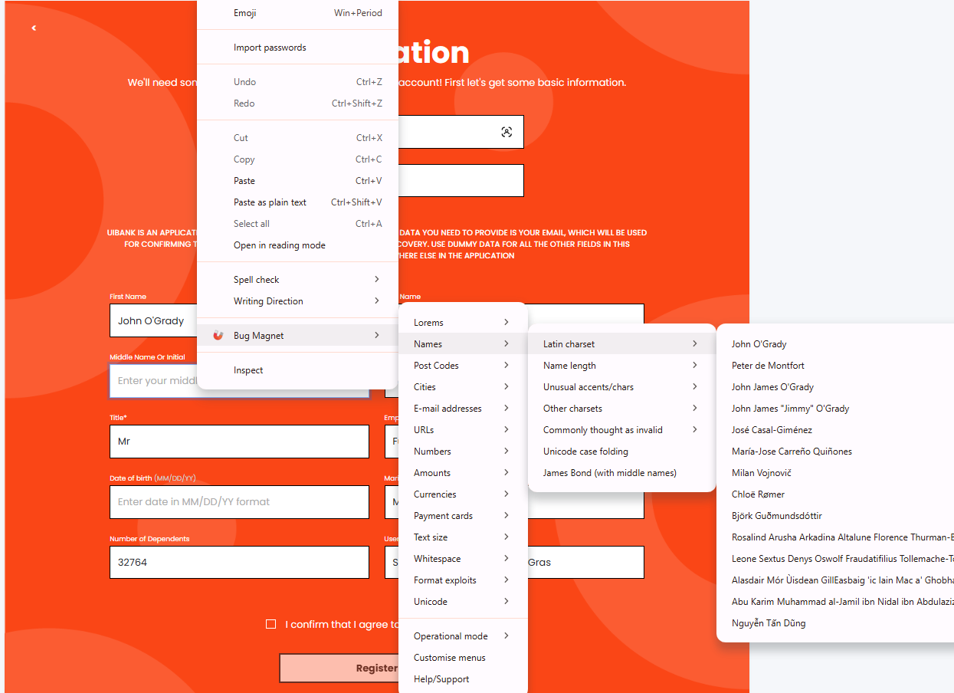

Use grammarly extension to correct the mistakes in your content
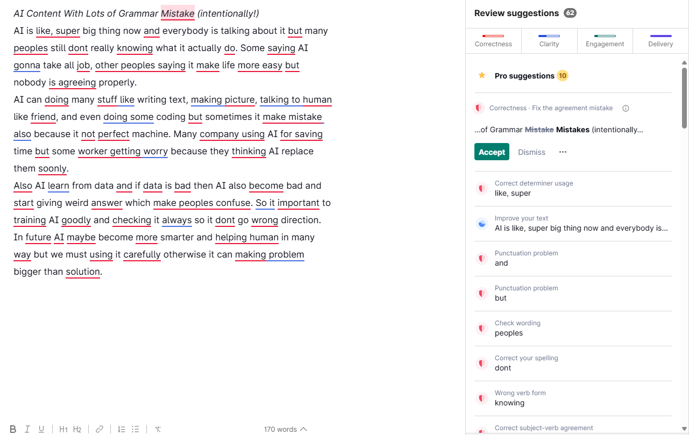
Corrected Paragraph
